LAB 7.1 SALES SUMMARY

* Create a mapping that gives the summary of all sales by item description, state, and month
* Use multiple sources
* Create and use Expression and Aggregator transformations in the mapping
* Use functions in the Expression transformation

Group columns in the Aggregator transformation.

**Solution**

* To get a summary of sales by item description, state and month,
* Collect data from various relational tables sources to consolidate the information.
* Create a relational target containing the summary wise details are created.

|  |  |  |
| --- | --- | --- |
| **TRANSFORMATION NAME** | **TYPE** | **DESCRIPTION** |
| ITEMS  ORDER_ITEMS  ORDERS  STORES | Relational Source Definition | Source definitions |
| SQ_SALES_SUMMARY_x | Source Qualifier | Data source qualifier for all source tables |
| EXP_SALES_SUMMARY_x | Expression | Link ITEM_DESC, PRICE, QUANTITY, DATE_ENTERED, and STATE from the Source Qualifier. Create a MONTH and YEAR port, and extract the month and year from the DATE_ENTERED. |
| EXP_SALES_SUMMARY_x | Expression | Link ITEM_DESC, PRICE, QUANTITY, DATE_ENTERED, and STATE from the Source Qualifier. Create a MONTH and YEAR port, and extract the month and year from the DATE_ENTERED. |
| AGG_SALES_SUMMARY_x | Aggregator | Link all ports except the DATE_ENTERED into the Aggregator. Create ports to hold the TOTAL_SOLD and TOTAL_PRICE. Create expressions in those ports to calculate the total quantity sold and the total price. You will want to select Group By for ITEM_DESC, STATE, MONTH, AND YEAR. |
| TGT_SALES_SUMMARY_x | Relational Target Table | Target definition |

FINAL OUTPUT:

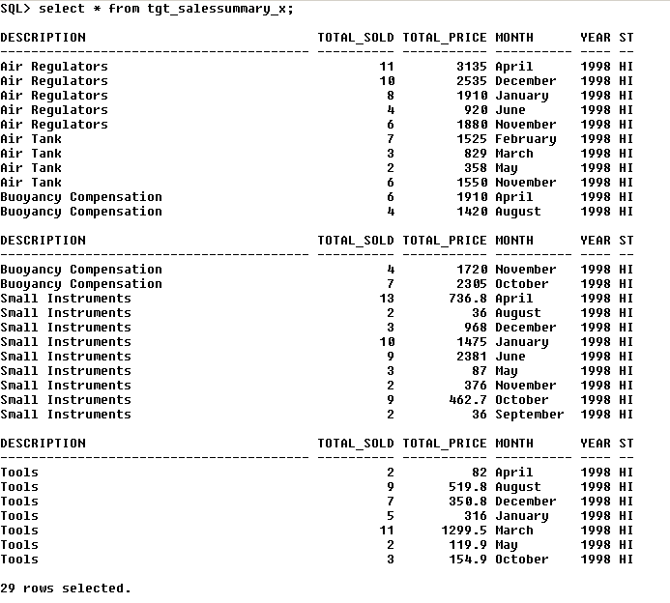

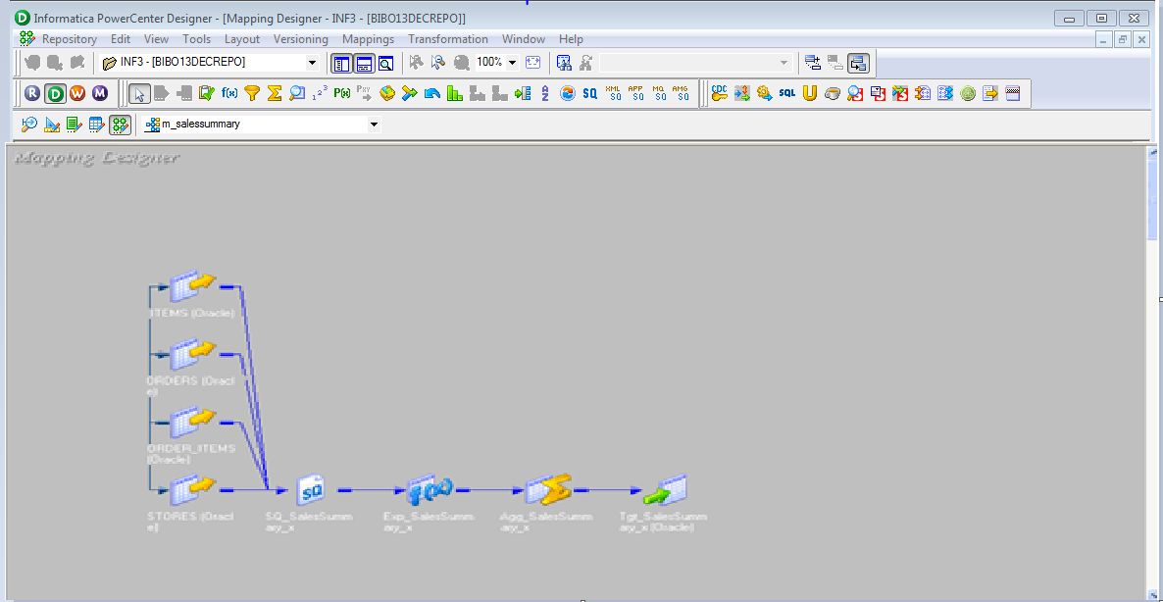

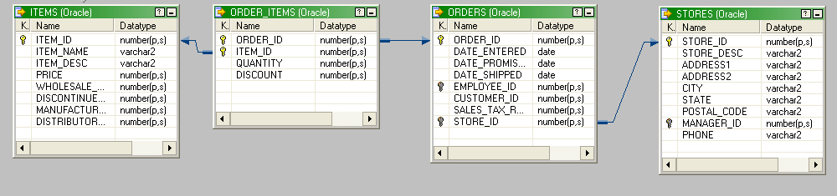

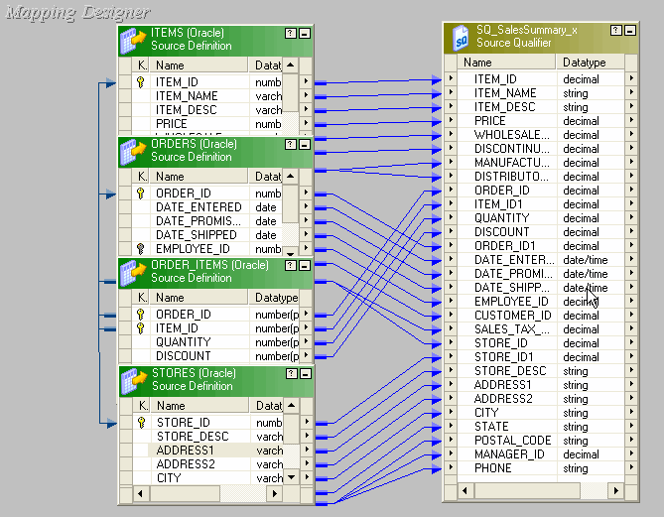

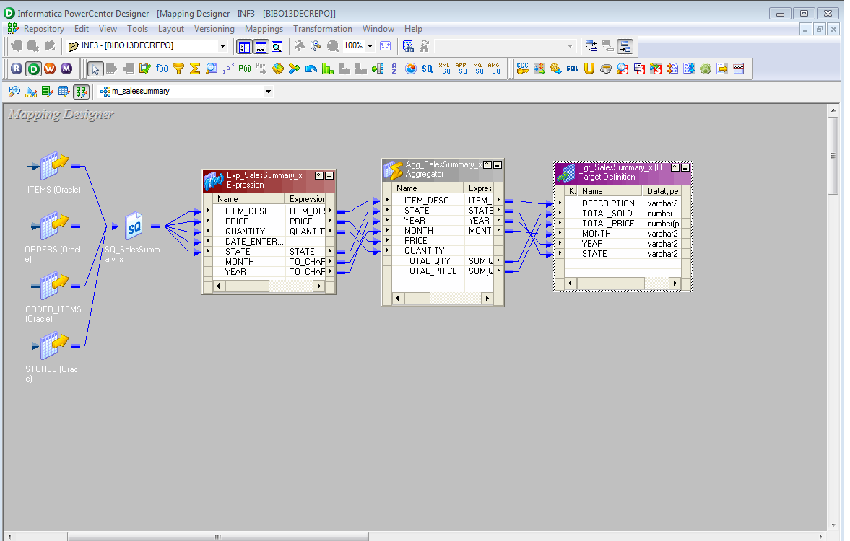

LAB 8.1 NEW CUSTOMER

GOALS:

• Create a mapping which reads from a flat file and creates a relational table consisting of new customers

• Analyze a fixed width flat file

• Configure a Connected Lookup transformation

• Use a Filter transformation to exclude records from the lookup transformation pipeline.

Solution

* Build a new target table that will contain data only for the new customers
* Use the Informatica tools to import and analyze the source files and create a target database table
* Use a Lookup Transformation to compare the Customer_ID from the flat file and the relational table
* Use a Filter transformation to test the result of the lookup and filter out matches. When no match is found for a given CUSTOMER_ID, the filter allows the potential customer record into the relational table
* The relational table will contain the list of potential customers, which can now be used for the promotional mailing.

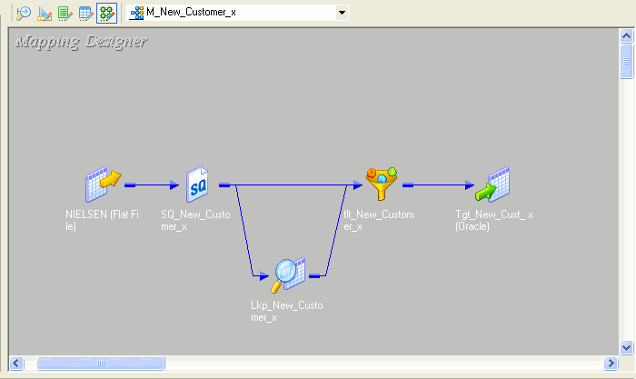

|  |  |  |
| --- | --- | --- |
| **TRANSFORMATION** | TYPE | **DESCRIPTION** |
| NIELSEN | Source | Flat file source definition |
| SQ_NIELSEN_X | Source Qualifier | Data source qualifier for flat file |
| LKP_NEW_CUSTOMER_X | Lookup | Check the CUSTOMERS table in the source database for occurrences of companies that are listed in the flat file. The condition will check NIELSEN.CUST_ID against CUSTOMERS.CUSTOMER_ID |
| FIL_NEW_CUST_X | Filter | Pass through all records from NIELSEN that do not match up with the CUSTOMER table (CUST_ID has no corresponding CUSTOMER_ID) |
| TGT_NEW_CUST_X | Target | Target definition (Relational Table) |

Final Output

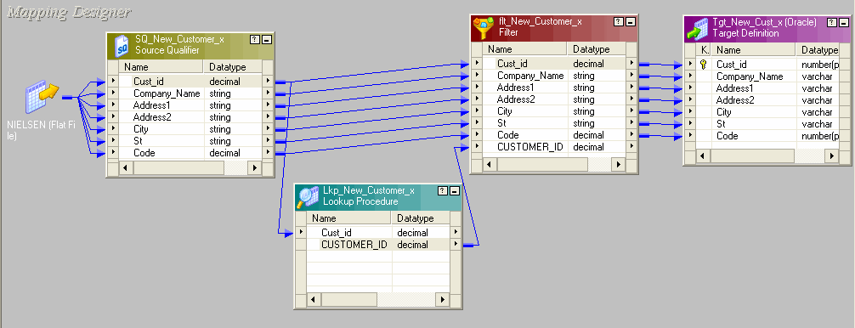

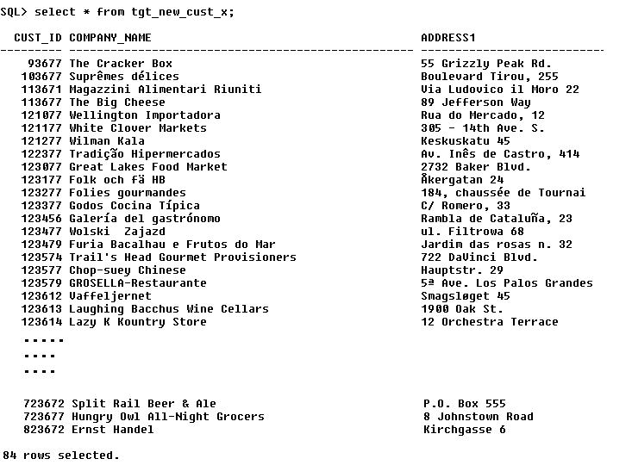

LAB 9.1 FLAT FILE JOIN

GOALS:

* Analyze delimited files
* Join heterogeneous sources

Use Aggregator and Rank transformations to provide top ten revenue producing items.

**Solution**

* Build a new target table that will contain only top ten selling items ranked by sales revenue
* Use PowerCenter tools to import and analyze the source files and create a target database table
* Use an Aggregator transformation to group
* Use a Rank transformation object to identify only top ten items to be sent to the target tables.

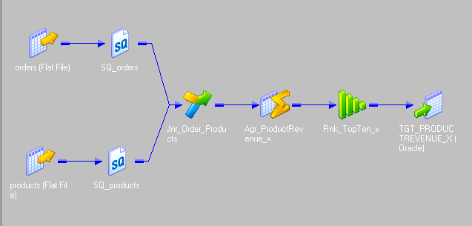

|  |  |  |
| --- | --- | --- |
| **TRANSFORMATION** | **TYPE** | **DESCRIPTION** |
| ORDERS, PRODUCTS | Sources | Flat file source definitions |
| SQ_ORDERS, SQ_PRODUCTS | Source Qualifier | Data source qualifiers for flat file sources |
| JNR_ORDERS_PRODUCTS_X | Joiner | Join the heterogeneous sources on the ITEM_NO field. The products file will be your master source. |
| AGG_PRODUCT_REVENUE_X | Aggregator | Calculate total price and quantity for items grouped by ITEM_NO, ITEM_NAME, and PRODUCT_CATEGORY |
| RNK_TOPTEN_X | Rank | Rank the top ten revenue-producing items |
| TGT_PRODUCTREVENUE_X | Target | Target definition (Relational) |

Final Output

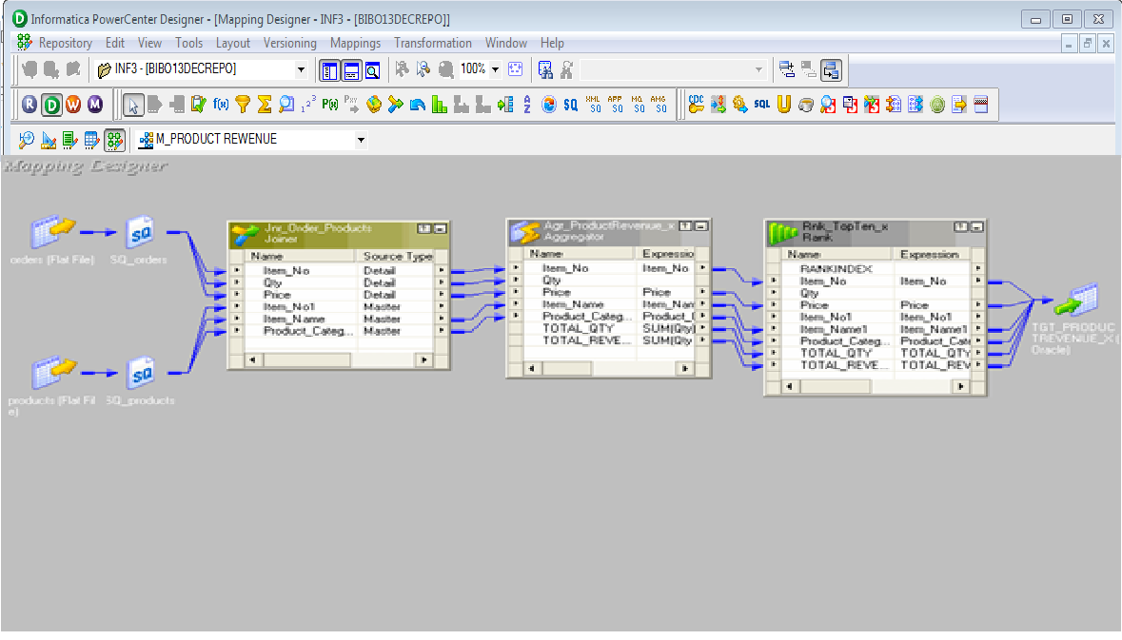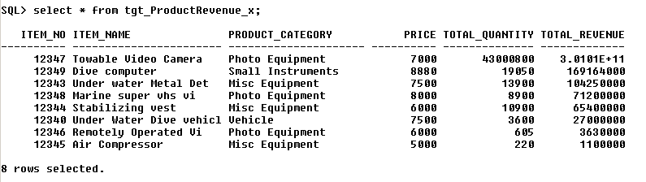

LAB 10.1 – CREATE A MAPPLET.

GOALS:

#### 52BLearn to create a mapplet

* Understand how to use variables.

**Solution**

* Build a mapplet that uses multiple sources and aggregate functions
* Create a variable within the mapplet for use in the aggregate functions
* In the next lab, use this mapplet to give the quarterly sales

|  |  |  |
| --- | --- | --- |
| **TRANSFORMATIONS** | **TYPE** | **DESCRIPTION** |
| ITEMS  ORDER_ITEMS  ORDERS | Source | Relational source definitions |
| SQ_SALESBYQTR_X | Source Qualifier | Data source qualifier to join the source tables and sort the data |
| AGG_ SALESBYQTR_X | Aggregator | Extract the month from the Date_Entered into a variable port. Call to that variable port when aggregating the quarterly sales |
| OUTPUT_SALESBYQTR_X | Target | Output transformation for the mapplet |

